**Project Overview**

Policy Innovation Lab (A1), Fall 2019

Patrick Campbell, Devraj Kori, Mansi Panchamia, Deepak Chawla

**GITHUB PAGE**

Project url: <https://github.com/jaxgoodlabs/Norwalk_Transportation>

Github Project Board: <https://github.com/jaxgoodlabs/Norwalk_Transportation/projects/1>

**TEAM ROLES**

Project Management - Patrick Campbell

Technology Specialist - Deepak Chawla

Coding / Analytics Specialist, Writing - Devraj Kori

Policy Research and Analysis, Writing - Mansi Panchamia

**PROBLEM STATEMENT**

How can the City of Norwalk streamline wayfinding and improve transportation related communication so that residents and visitors can more easily and cost-effectively get to where they want to go without leaving underserved residents behind?

**GOALS & OBJECTIVES**

To provide the residents and visitors of Norwalk a one stop mobility service to enable them to move more efficiently around the city. Streamlining WayFinding, analysing and suggesting what can be improved upon. Devise a system that allows residents to park outside the urban core and rely solely on multi-modal transit options to get into and around the city. If possible, integrate, with bike share and microtransit. Devise strategies to promote this tool. Creation of a template for user research was also suggested (see problem 3).

**CONSTRAINTS, PROBLEMS, & RISKS**

1. Technology is not available equally to everyone. Lower income and old people may not have the same access to technology or the skills to use it. This can be seen with microtransit as older residents and lower income households haven’t adopted it as much as compared to fixed transit. Approximately 15% of Norwalk residents are estimated to not own smartphones.
2. Current plans for new systems may not fully accommodate user needs due to lack of user data.
3. Bureaucratic barriers to implementing new systems.
4. Residents lack awareness of all available transportation systems and how they can like together.
5. If microtransit systems replace fixed-route public transit systems, microtransit infrastructure may not cost-effectively meet the needs of residents that depended on fixed line routes
6. Funding may become an issue as these pilot services scale.
7. Public perception of top-down government / transparency / communication
8. Downtown connected by 2.5 mile strip, somewhat not clearly connected to highway!
9. New England weather makes walking long distances challenging and bikeshares unusable during certain months.

**SUCCESS METRICS**

As per client

The following metrics were proposed by the client as being useful for identifying weaknesses in the current system and guiding future transportation-related development:

1. Usership rates per route and mode of transportation (bike/ped, buses/fixed route, microtransit, etc.) and demographic breakdown
2. Wait and travel times per route and mode of transportation
3. Vehicular deaths and injuries (Vision Zero)

Additional metrics

The following additional metrics were identified by the group as representing untapped or under-explored opportunities:

1. Public support / satisfaction (with current transportation system as well as City’s transportation plans/proposals)
2. Traffic / congestion patterns
3. Patronage of downtown venues and events
4. Transparency and better communication with the public and inter-department

**REVIEW YOUR RESEARCH**

Context of Design Challenge

* See Data Sets and Source Documents in Appendix below
* Refer also to [Research Report](https://docs.google.com/document/d/1T8M6lj6NvwbqydZh1qmAvfqD6EzfCCO-XK7e0RtqJsY/edit?usp=sharing)

Recent Innovations

* Have other cities tried phasing out fixed-route transit in favor of a more robust microtransite system? If so, who are they? Are there differences between these cities and Norwalk that might influence the likelihood of success?
* How well do different demographics manage integration of new technologies into the transportation system?
  + Older individuals with less technical capacity?
  + Lower-income populations with less access to smartphone technology?
* How well do different demographics manage drastic changes in transportation systems?
  + Status quo and trends in uptake per demographic category?
  + Are there programs or other means by which a city can ease this transition?
    - Phasing
    - Physical signage to supplement apps, etc.
    - Media / public service announcements
    - Educational programs / workshops

Precedent Solutions

* Consider adopting methodology from another city with similar transportation and mobility challenges. Confirm city conditions are comparable using [digital twin](https://datasmart.ash.harvard.edu/) or [peer city](https://www.chicagofed.org/region/community-development/data/pcit) tools.

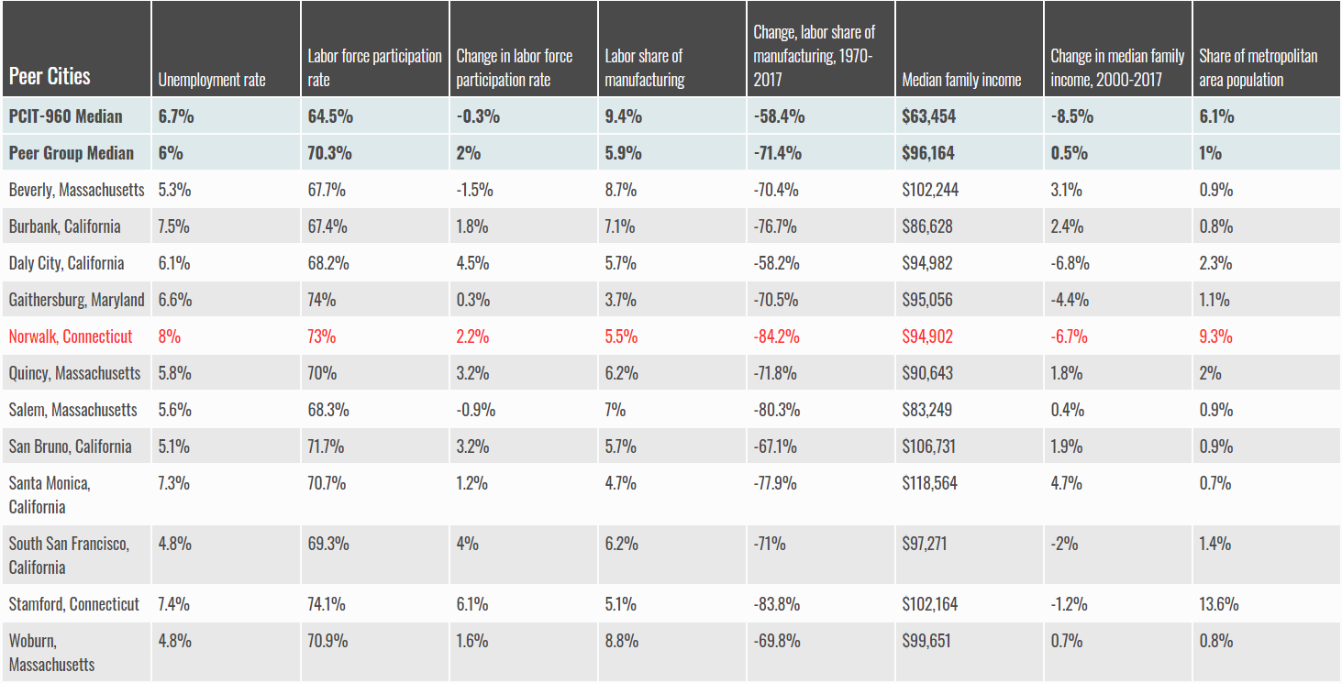

Secondary Research

* See Data Sets and Source Documents sections below

**DEFINE YOUR AUDIENCE**

Affected Groups

* Patrons of current transportation systems
  + Fixed route (buses/shuttles)
  + Microtransit
  + Bike
  + Pedestrian
* Interest and Advocacy groups
  + See Research Plan for a list of these groups and contacts
* Underserved populations
  + Single parents
  + Low income (geographic factors and route availability, car ownership, etc.)
  + Older population (tech challenges with microtransit app, etc.?)
* Individuals with disabilities
  + Visually impaired
  + Ambulatory challenges (walkers, wheelchairs, etc.)
* Commuters

Peripheral Groups

* Children of single parents
* Family members of disabled individuals
* Employers of underserved populations
* Local commerce (business owners, employees, etc.)
* Car owners - may be displaced by elimination of parking, modal change, etc.
* Visitors - how does a resident-focused transportation system affect tourism, etc.?
* Taxpayers - how much does the new plan cost relative to the old/existing system
* Governing authorities (Parking Authority, DOT, etc.)
  + Capacity
  + Budgeting / funding sources

**APPENDIX 1. DATA SOURCES**

1. Parking areas - <http://www.norwalkpark.org/map>
2. Ride sharing: <https://www.cmu.edu/metro21/projects/ridesharing.html>
3. Bike/Walk Norwalk - <https://www.norwalkct.org/1503/Norwalk-BikeWalk-Commission>
4. Norwalk Bike Routes - <http://norwalk.maps.arcgis.com/apps/webappviewer/index.html?id=5d6af0d560094b7bb9c291e9a043bc88>
5. Norwalk maps library - <http://tomorrow.norwalkct.org/resources/?maps=1&go=Go>
6. Connecticut Data - <http://magic.lib.uconn.edu/connecticut_data.html#roads>
7. Norwalk Open GIS Data - <http://gis-norwalk.opendata.arcgis.com/search?page=2>
8. Transportation related Mapping - <https://portal.ct.gov/DOT/PP_Bureau/Documents/Maps>
9. Public bus/shuttle routes - <https://www.norwalktransit.com/norwalk>

* Requested shapefile from TMP team on 9/13

1. Parking survey results?

* Requested from TMP team on 9/13

1. Norwalk GIS - <http://norwalk.maps.arcgis.com/home/search.html?q=owner%3A%22Norwalk_GIS%22&restrict=false&start=1&num=20>

* Files in wrong format for ArcGIS Pro

1. City of Norwalk, CT Interactive map - <http://host.cdmsmithgis.com/norwalkct/>

**APPENDIX 2. SOURCE DOCUMENTS[1]**

1. 2019–2029 Norwalk Citywide Plan of Conservation & Development (POCD) - <http://tomorrow.norwalkct.org/citywide-plan/>
2. Incentivising ride sharing program: <https://mobility21.cmu.edu/wp-content/uploads/2019/09/Recap-187.pdf>
3. Master Connectivity Plan -
4. Norwalk 2018-2019 Pedestrian Plan - <https://www.norwalkct.org/DocumentCenter/View/13707/Pedestrian-Plan>
5. Norwalk Pedestrian and Bikeway Transportation Plan - <https://www.norwalkct.org/DocumentCenter/View/9140/Norwalk-Pedestrian-and-Bikeway-Transportation-Plan-January-2012?bidId=>

**APPENDIX 3. LINKS & RESOURCES**

#### Norwalk Transportation, Mobility and Parking homepage - <https://www.norwalkct.org/1827/Transportation-Mobility-and-Parking>

#### Norwalk Wayfinding - <https://www.norwalkct.org/1546/Wayfinding>

#### Transit-Oriented Development: <https://www.cmu.edu/metro21/projects/route-51-transformation.html>

1. Wheels2u Microtransit Program - <https://www.norwalktransit.com/wheels2u>; <https://wheels2unorwalk.com/>
2. Norwalk Transit District App - <https://www.norwalktransit.com/>
3. Norwalk Mayor’s Dashboard - <https://www.norwalkct.org/1818/Mayors-Dashboard>
4. Successful government apps: <https://www.theguardian.com/public-leaders-network/2017/jan/23/seven-successful-government-digital-service-apps-technolog>
5. Norwalk Redevelopment Agency - <https://norwalkredevelopmentagency.com/goals/>
6. Connecticut DOT - <https://portal.ct.gov/DOT/Publictrans/Bureau-of-Public-Transportation/PublicTrans---Left-Navigation>
7. ADA Paratransit Services - <https://portal.ct.gov/DOT/Publictrans/Bureau-of-Public-Transportation/Paratransit-service>
8. CT Travel Smart tool - <https://cttravelsmart.org/>

**APPENDIX 4. KICK-OFF MEETING DEBRIEF**

Kick-off meeting

Friday, September 6th, 2019. 4:00PM - 5:00PM

Participants

Kathryn Hebert (Director Transportation Mobility Parking / President New England Parking Council); Sabrina Church (Director of Business Development & Tourism); Patrick Campbell; Deepak Chawla; Devraj Kori; Mansi Panchamia.

Jessica Casey (Chief of Economic and Community Development) not on call.

Objectives

1. Introductions
2. Define roles and expectations
3. Clarify project scope/ goals / progress/ constraints/ opportunities/ success metrics
4. Identify resources available to our team
5. Establish communication protocol, including date/time for next meeting

Progress To-Date

* About to launch a bikeshare program
* Parking payment has an app
* Wayfinding has an app
* Signals (90) → moving toward adaptive signal system (functional by Nov.)
* Released a dashboard to update people: <https://www.norwalkct.org/>

Summary

Post partner introductions, an overview of Norwalk was given. Current scenario, projects in the pipeline and future aspirations for the city of Norwalk were discussed. The scope and expectations of the project were established. For weekly updates, Friday 3:00 PM was decided as the tentative day and time.

Meeting Schedule and Format

Fridays, 3:00-4:00 PM via Google Hangouts

1. All data sets and source documents saved in shared project folder in Google Drive.